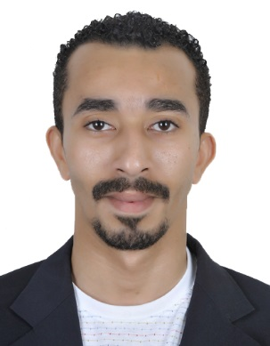**Mohamed Alsabaie**

**Birth date:** August 10, 1986

**Nationality:** Bahraini

**CPR:** 860808033

**Contact: +973** 39437468

**E-mail:[mohamedalsabri@yahoo.com/](mailto:mohamedalsabri@yahoo.com/)[alsabrimohamed32@gmail.com](mailto:alsabrimohamed32@gmail.com)**

**Career:**  well experienced in culinary Arts specialty in grade manger kitchen as well main kitchen. Tourism industry related work experiences, certified culinary Arts Graduate, well spoken and written in English, computer literate, fast learner, and customer & employee service oriented.

**Objective:** An experienced in hotel industry: practitioner in food preparation and operation which could deem laurel to food business which eventually contributes in company’s revenue drive whilst working in the environment with same objective of improving career growth and improving people.

**ACADEMIC BACKGROUND**

**Graduate of :** Hospitality & catering

**Major :** Food preparation and cooking (Sept-2002-June 2003)

**Institution:** Gulf College of Hospitality & Tourism

Culinary department

Muharraq, kingdom of Bahrain

**Course completed**:**\***Communication / English Language

* Information Technology (i.T.)

Application of Numbers.

**WOEK EXPERIENCE**

**COMPANY:** Al safir hotel, juffair Bahrain

**POSITION:** Junior sous chef

**DURATION:** 28 November 2013 to March 2017

**COMPANY:** villa mamas, saar Bahrain

**POSITION:** sr.sous chef

**DURATION:** March 2017 to September 2017

**COMPANY:** ahmed hassn ali company, caffe di gio as well basilico juffair Bahrain.

**POSITON:** head chef

**DURATION:** September 2017 till 10/10/2017

**COMPANY:** Park inn hotel al Khobar, Saudi Arabia

**POSITION: Demi** chef de partie

**DURATION:** May 2009 until March 2013

**COMPANY:** Intercontinental Regency Bahrain

**POSITION:** Second Cook

**DURATION:** July 2005 until April 2009

**COMPANY:** Mervana restaurant

**POSITION:** head chef

**DURATION: 2017 November** till march 2018

**Other companies affiliated:**

**COMPANY:** Sheraton Bahrain, hotel & towers

**POSITION:** housekeeping Attendant

**DURATION:** July 2003 until April 2004

**COMPANY:** McDonald bab al Bahrain branch

**POSITION:** Crew2002 until 2003(part time job while studying at college)